Install PIP on Window

To install pip, download **get-pip.py** via [*https://bootstrap.pypa.io/get-pip.py*](https://bootstrap.pypa.io/get-pip.py) to a directory on your computer.

After that, navigate into the directory in your command prompt window and run

python get-pip.py.

To verify a successful installation in your command prompt, navigate into C:\Python27\Scripts, then run

pip --version

you should get:

pip 9.0.1 from c:\python27\lib\site-packages (python 2.7)

How to Install PyVisa?

From command prompt, run

*pip install pyvisa*

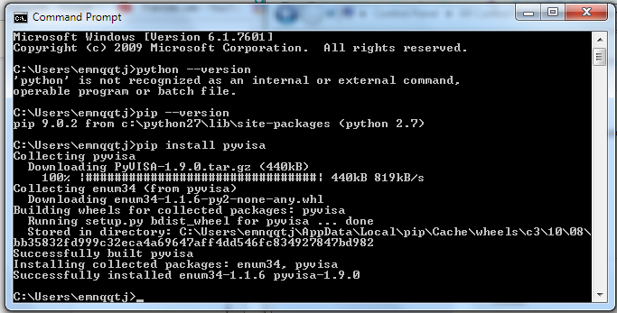

Then run:

* “python –m pip install PySide”
* “python –m pip install pyvisa”
* “python –m pip install pyserial”
* “python –m pip install pyqtgraph”

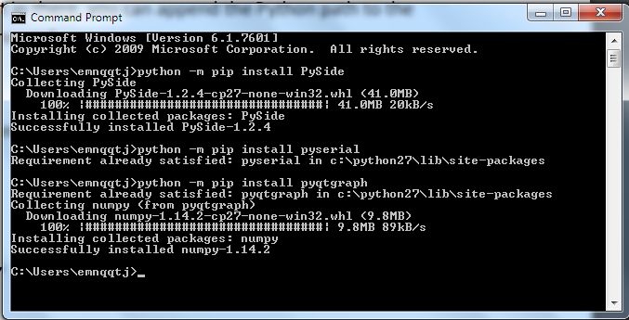

Install PyGMI

Download a window installer: <https://github.com/Patrick-Cole/pygmi/releases>